**Experiment 4**

**List out the required processes to be coded along with the required flow charts.**

This introduction to the flowchart provides an overview of the major steps involved in a blood donation project, from initiation to project assessment. Depending on the complexity and specific goals of your project, you can customize and expand upon these steps as needed.

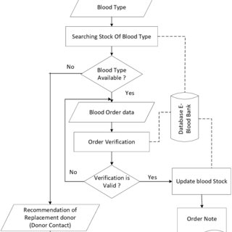

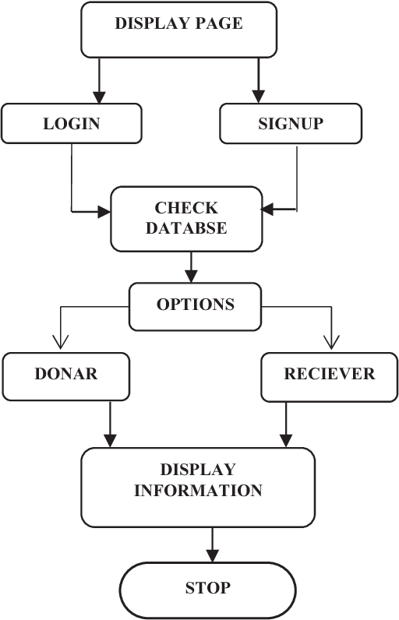

**Fig. Flow Chart**